C/C++ SENTENCE FORMATTING LAB REPORT

1) Enter your name, student ID, platform (Mac or PC) and date
Name and Student ID: Jay Gupta, Student ID: 0961979
Class: CIS054 C/C++ Programming
Platform (Mac or PC): PC
Date: 4/12/2020

DESCRIPTION:
1) Input a sentence from the keyboard ending in a period ✔
2) Change all whitespace characters to a space ✔
3) Remove multiple spaces ✔
4) Capitalize the first character of the sentence ✔
5) Make all other characters lower-case ✔

Example:
input → this Is A tEst.
Output -> This is a test.

LAB REPORT:
2) Determine the Inputs, Processing and Outputs before creating the program
INPUTS | PROCESSING | OUTPUTS
- Sentence which isn’t formatted correctly (has a period at the end) | - Take in the input as a character string.  - Loop through the sentence, shifting the sentence appropriately in order to remove tabs, newlines, and multiple spaces.  - Capitalize the first letter, turn all other letters into lowercase.  - Output the new, correctly formatted string. | - Properly formatted sentence, with modifications described in description

3) Fill in the EXPECTED & ACTUAL RESULTS
TEST DATA VALUES  Provide at least two different examples strings to format | EXPECTED RESULT  Computed values before the program is run | ACTUAL RESULT  Fill in the output displayed  by the program
1. i lIKE CIS 054 because the  teacher is cool.  2. this Is a TEST of mY prograM. | 1. I like cis 054 because the teacher is cool.  2. This is a test of my program. | 1. I like cis 054 because the teacher is cool.  2. This is a test of my program.

DISCUSSION:
4) Complete the DISCUSSION section. It does not need to be long, but it needs to be complete.
4a) What did you do to develop the program? ("Followed the Directions" is not a complete description)

I looked at the slides to get an idea of what the program is looking for, and then I tried it on my own. I ran into a few issues which I will elaborate on in the next question, and for the most part, it was easy. I was surprised that we weren’t using strings, but rather arrays; I guess it makes sense given the functionality of arrays.

4b) What problems did you have and how did you overcome the problems?

I had a few problems concerning the spaces and tabs, generally how to fix the problem. I wanted to fix it on my own, but in the end, in order to conserve time and not burn-out, I looked at the solution you gave in the slides. I thought it was a pretty naïve approach, but the important thing is it worked. I quickly realized after a few runs that you have to put an else if statement to catch for tabs and newlines, and I used the same approach to solve that as well.

If I had more time and energy, I would capture the whole sentence in the array, and loop through removing the newlines, extra spaces, and tabs. I feel this would do justice to the time and space complexity, as the current approach would take a lot of memory space given a paragraph or even a whole file.

PROGRAM OUTPUT:
5) Show screen shots for at least TWO strings that were formatted.
Refer to previous lab assignments for instructions on how to capture a screen or portions of a screen for either the PC or a Mac.

1.
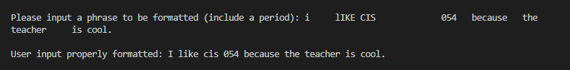

2.
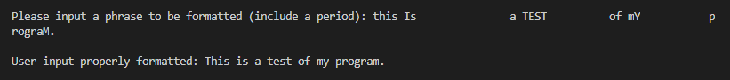

PROGRAM LISTING:
6) Copy and paste the code that YOU typed to make the program work. Your program should include a comment block at the top that shows the name of the program, date, version and your name.
/**
* Jay Gupta
* SJECCD CIS 054
* 4/12/2020
* Dan McElroy
* Module 10
* C++_Sentence_Formatting.cpp (V1.0)
* Input: Poorly formatted sentence
* Ouput: Properly formatted sentence, with modifications from project description.
*/

#include <iostream>
using namespace std;

int main() {
char userInput[200];

cout << endl << "Please input a phrase to be formatted (include a period): ";
cin.getline(userInput, 200);

// clear all whitespace
int i = 0;

// loop through the whole sentence, until the end
while (userInput[i] != '\0') {

// if the current character and the next character over are spaces
if (userInput[i] == ' ' && userInput[i + 1] == ' ') {
// shift the whole remaining sentence 1 to the left, to get rid of the second space
for (int j = i; userInput[j]; j++) {
userInput[j] = userInput[j + 1];
}

// continue to the next iteration, we don't want i increasing; we want to stay in the same place
// until all the extra spaces are gone
continue;
} else if (isspace(userInput[i])) { // also check for tabs and newlines
if (isspace(userInput[i + 1])) { // if the character after the first is also a newline/tab
for (int j = i; userInput[j]; j++) { // shift the whole thing to the left, like above
userInput[j] = userInput[j + 1];
}
continue;
} else {
userInput[i] = ' '; // if there's only one tab/newline, convert it to a space
}
}

i++; // go on to the next character
}

// ensure that the first letter is capitalized
userInput[0] = toupper(userInput[0]);

// make all other letters lowercase
for (i = 1; userInput[i]; i++) {
userInput[i] = tolower(userInput[i]);
}

cout << endl << "User input properly formatted: " << userInput << endl << endl;

return 0;
}

